Building AI Application Challenge 2026
Builder Progress Log & Submission Workbook
Days 2–8 (Environment → Build → Evaluate → Deploy → Submit)

Use this document as a living workbook. Update it daily with links to your repo, demos, screenshots, and decisions.

0) Participant & Project Metadata
Participant Name | Nevin Pinto
Email | pintonevin@gmail.com
Timezone | GST (Dubai)
Start Date | 5’th September 2026
Path (select one) | ☐ Airia ☒ LLM/API Integration (implemented with Google AI Studio) ☐ No-Code/Low-Code
Project Repo URL (GitHub) | https://github.com/Nevin-CS/nevin-chatbot-ai-math-learning-assistant
Demo / App URL (if available) | https://nevin-chatbot-ai-math-learning-assistant.ai.studio/
Quick links (keep updated):
- ☐ GitHub repo (public link)

- ☐ Deployment link (Hugging Face / Streamlit / other)

- ☐ Demo video link (Loom/YouTube)

- ☐ LinkedIn progress post URL

- ☐ Tweet/X progress post URL (if applicable)

3) Data / Knowledge Sources Inventory
Day 2 focus: list your data sources clearly. This becomes critical for quality, evaluation, and judging.
Source | Type | Owner / License | Format | Size | Update freq | Access method | Preprocessing needed | PII/Sensitive? | Status
Student-entered Math questions | User input / problem text | User-provided | Plain text / mathematical notation | Variable per query | Per interaction | Chat / form input | Normalize notation and clarify ambiguous wording when needed | Low risk; avoid entering personal data | Primary source for initial prototype
Project teaching prompt / Math explanation rules | Project-authored instructions | Nevin / project | Text prompt | Small | Refined during testing | No-code platform / prompt configuration | Prompt refinement based on test results | No | Drafted for Day 2
External knowledge base / RAG corpus | Not used in initial version | N/A | N/A | N/A | N/A | N/A | N/A | N/A | Not planned for initial prototype
If you are doing RAG / search:
- ☐ Corpus assembled — Not required for the initial non-RAG prototype
- ☐ Chunking strategy defined — Not applicable at this stage
- ☐ Embedding model selected — Not applicable at this stage
- ☐ Vector store selected — Not applicable at this stage
- ☐ Citation strategy — Not required for the initial user-question workflow
- ☒ Data safety considered — students should avoid secrets/PII; use only appropriate learning content

4) LLM / Model Selection & Experiments
Capture what you tried, what worked, and why you chose your final stack.
Candidate | Provider | Why considered | Prompting approach | Quality notes | Latency notes | Cost notes | Decision
Gemini (AI Studio-managed) | Google Gemini | Primary live model path for broad mathematics tutoring and multi-turn follow-up. | Math-only scope; concept → steps → verification → final answer → learning tip. | Live application working; formal full-set accuracy benchmark remains to be recorded. | Tracked in the evaluation harness. | Free access for learners; provider quotas remain an owner/deployment constraint. | Selected live path for Day 4.
OpenAI function-calling pattern | OpenAI reference pattern | Used as an architectural example for trusted tool/function execution, not as the live paid provider. | Route a supported calculation to a deterministic tool, validate arguments, execute, then explain. | Pattern adapted to arithmetic and simple linear-equation verification. | Local tool execution reduces provider calls for supported checks. | No paid OpenAI API key required for Day 4. | Reference architecture only.
Deterministic math tools | Local JavaScript | Verify arithmetic expressions and simple linear equations before/alongside the LLM. | Strict parsing and trusted calculation output. | Covered by automated tests. | Near-instant local execution. | No provider cost. | Enabled as verification support.
Prompt versions (for LLM/API or No‑Code tools):
Prompt ID | Goal | System constraints | Few-shot examples? | Tools/Actions used | Notes / Results
P1 – Math-only tutor | Teach a supported math question clearly. | Refuse unrelated topics; identify concept; numbered steps; verification; final answer; learning tip. | No | Gemini + optional deterministic verifier | Implemented in `src/prompt.js` and the AI Studio build.
P2 – Learning-level adaptation | Adjust explanation depth for middle school, high school, college, or teacher use. | Preserve correctness while changing vocabulary and detail. | No | Conversation context + level field | Included in the live app design and API request.
P3 – Evaluator / judge | Score scope, correctness, step validity, clarity, verification, coherence, privacy, and helpfulness. | Return structured JSON scores from 0 to 1. | No | Prepared LangSmith-style evaluator prompt | Prepared for offline/online evaluation; not claimed as a live paid service.

5) Day 2 — Environment Setup & Initial Development
Deliverable for Day 2: no full project submission today—prepare your environment + tech stack/tooling + initial work evidence.
Environment setup checklist (tick what applies):
- ☐ Repository created and initial commit pushed — Done
- ☐ README created (project goal + how to run) — Done
- ☐ .gitignore configured (no secrets) — not yet applicable to no-code workspace
- ☒ Platform workspace / no-code development environment planned and structured for the prototype
- ☐ Dependencies installed and pinned — Done
- ☐ API keys stored safely — To be configured only if the selected platform/API requires a key
- ☐ Basic 'hello world' run completed locally — Not applicable to the current no-code setup
- ☐ First model/API workflow run — Pending initial connection/test
- ☐ Folder structure created — Done
- ☒ First prototype interaction flow defined: Question → Analyze → Identify Concept → Step-by-Step Solution → Explanation

Evidence (links):
GitHub repo URL | https://github.com/Nevin-CS/nevin-chatbot-ai-math-learning-assistant
Commit hash / tag | Initial GitHub Pages prototype committed on the main branch. Copy the exact commit hash from GitHub if the submission form requires it.
Screenshot(s) link | https://nevin-cs.github.io/nevin-chatbot-ai-math-learning-assistant/ — live prototype screenshot included below.
Notes on setup decisions | No-Code/Low-Code-first prototype using HTML/CSS/JavaScript on GitHub Pages. The UI and local math flow are working. Day 3 focuses on the intelligence layer: structured tutoring prompts, model comparison, secure API-integration planning, testing, feedback, and robustness.

Project Management: Day 1:
What you built today (first version development log):
• Deployed minimum viable Nevin Chatbot UI. Version 1 Nevin Prototype consists of Student-Centric AI Math Learning Assistant UI, Sample Math Question, Sample Learning-by-Steps flow, explain and also describe concept, I will also navigate and link to the Assistant project and give details about this in the coming days.
• Developed base-flow: Student Question → Analyze Question → Determines Math Concept → Creates Learning-by Steps Solution → Explain Concept
• I wrote the initial tutoring prompt to have Assistant teach student how solution is reached and have them check work vs providing a solution.
• I have created initial testing playbook to ask AI Math Learning Assistant math questions from basic to complex and evaluate for accuracy, understandability, uniformity and relevance to student.
Blockers / things you screwed up (and how you fixed them):
• No provider decided on. Remediation: I compared low-code or LLM options that can run my same set of test questions prior to deciding on technology stack.
• Biggest quality concern is incorrect explanations. Remediation: build test set, iterate on prompts, fact check output, and implement tighter validation on the coming days.

Day 3 — Building the Brain of Your App
Day 3 focus: enhance the application intelligence, strengthen the API/LLM integration plan, define evaluation evidence, and connect the brain of the app to the existing user experience.
Day 3 Checklist
☒ Core logic implemented for the current local workflow: question → concept → steps → result → learning check.
☐ Live LLM/API integration is still pending; the public GitHub Pages app does not expose any private API key.
☒ 12 test questions/examples drafted as the initial “exam set”.
☒ First rough baseline established: the deployed prototype handles supported arithmetic and simple linear-equation flows locally.
☒ README and repository are available publicly; API/backend run instructions will be added when the secure integration is implemented.
☒ Initial UI integration is already live on GitHub Pages.
☐ Multi-turn LLM context, retries, rate-limit handling and provider fallback will be implemented with the secure API layer.
☐ Thumbs-up/down feedback will be added to collect user feedback on answer quality.
Model / LLM Candidates
OpenAI GPT / ChatGPT Plus: used as the primary prompt-prototyping and model candidate for structured math tutoring. ChatGPT Plus itself is not an API credential; live application integration requires a separate secure OpenAI API setup.
Gemini Pro: comparison candidate for math reasoning, explanation clarity, consistency, latency and cost. The same question set and rubric will be used for a fair comparison before choosing a production model.
API Enhancement & Robustness Plan
• Multi-turn conversations: preserve recent question context so follow-up questions such as “why did you divide by 2?” can be answered coherently.
• Error handling: catch timeouts, invalid responses and rate-limit errors; show a friendly retry message instead of failing silently.
• Retry and fallback: retry transient failures once, then use a safe fallback flow or alternate provider if configured.
• Performance: keep prompts concise, avoid unnecessary repeated context, and measure response latency before choosing a final model.
• Security: keep provider API keys on a server/serverless backend, never in browser JavaScript or the public GitHub repository.
• Feedback: add thumbs-up/down and an optional short comment so student feedback can inform prompt and model improvements.
Day 3 Progress Report
Application concept
Nevin Chatbot is an AI Math Learning Assistant designed to help students understand mathematics rather than only receive final answers. The Day 2 interface is already deployed on GitHub Pages. Day 3 focuses on the app brain: tutoring prompts, model candidates, evaluation examples, error handling, context management, feedback, and the path from the current local solver to a secure LLM-powered assistant.
What I worked on today
• Reviewed and documented the current local math-learning workflow.
• Added OpenAI GPT/ChatGPT Plus and Gemini Pro as model candidates for structured comparison.
• Defined three prompt roles: step-by-step tutor, concept simplifier, and verify-before-answer.
• Planned multi-turn context, timeout/rate-limit handling, retries, provider fallback, response verification and user feedback.
• Kept the deployed public application free of provider secrets and documented the need for a secure backend for live API calls.
Initial 12-question exam set
1) 18 + 6 × 4 2) (12 − 4) ÷ 2 3) 2x + 3 = 11 4) 5x − 7 = 18 5) 3(x + 2) = 15 6) Factor x² + 5x + 6 7) Solve x² − 9 = 0 8) Explain the Pythagorean theorem 9) Find the slope through (2,3) and (6,11) 10) Differentiate x² + 3x 11) Explain what a derivative means to a beginner 12) A word problem requiring equation setup and solution.
Challenges encountered and how I addressed them
The biggest technical limitation is that a static GitHub Pages site cannot safely contain private LLM API keys. My solution is to keep the current front end public while planning a secure backend/serverless endpoint for provider calls. The second challenge is mathematical reliability: broader questions require stronger verification than the current local parser, so model answers will be tested against known solutions and a consistent evaluation rubric before production use.
Current project status and next adjustments
The project now has a working deployed interface, a local math-learning flow, a documented model-selection plan, three tutoring prompt roles, and an initial test set. Next I will connect the interface to a secure LLM endpoint, compare OpenAI GPT and Gemini Pro, add context/error/fallback handling and feedback controls, and measure accuracy, teaching clarity, latency, reliability and cost.
Evidence & Links
GitHub repository: https://github.com/Nevin-CS/nevin-chatbot-ai-math-learning-assistant
Live demo: https://nevin-cs.github.io/nevin-chatbot-ai-math-learning-assistant/
LinkedIn progress post: https://lnkd.in/p/dghs-DvH
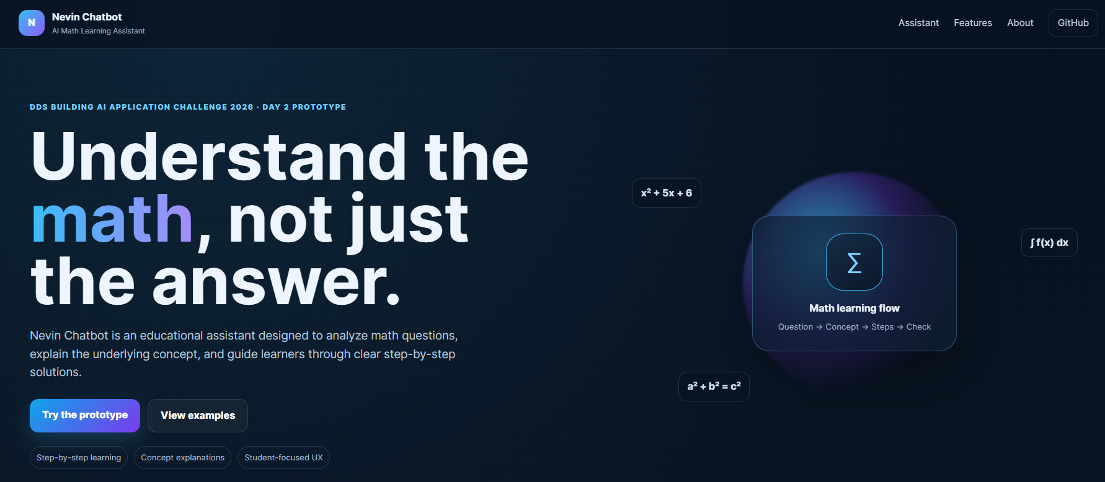
Day 2/Day 3 evidence: deployed Nevin Chatbot prototype on GitHub Pages.
Blockers / Help Needed
• Live provider integration is not complete yet. A secure backend and provider API credentials are required. ChatGPT Plus does not itself provide an OpenAI API key; Gemini also requires the appropriate API configuration for application use.
• Exact provider/model choice remains open until both candidates are tested on the same math-question set.
Day 4 — Optimizing Integration & Application Evaluation
Day 4 focus: move Nevin Chatbot from a local/static prototype to a real Gemini-powered tutoring application, evaluate the integration, strengthen reliability and security, and document evidence from the live deployment.
Day 4 Checklist
☒ Evaluation approach defined: representative math questions plus checks for explanation clarity, correctness, verification, multi-turn context, usability and failure behavior.
☒ Prompt/model iteration completed through three Google AI Studio build prompts: initial product build, production/security audit, and DDS judge-ready polish.
☒ Live Gemini-powered application deployed and working in Google AI Studio.
☒ Multi-turn tutoring, learning-level personalization, friendly error states, retry behavior and user feedback controls included in the production-oriented design.
☒ Security improved by keeping Gemini access in the hosted/server-side application flow rather than exposing a provider key in public GitHub Pages JavaScript.
☒ Accessibility and SEO requirements added to the production review: semantic structure, keyboard access, focus states, metadata, mobile responsiveness and transparent AI limitations.
☒ Legacy Day 2 fallback message removed from the new AI Studio application so broader math questions use the Gemini tutoring workflow.
☒ Automated evaluation completed: 32/32 local checks passed. A live-provider run against the full evaluation set remains the next measurement step before claiming quantitative production accuracy or latency.
Day 4 Integration & Evaluation Notes
• Architecture decision: I initially explored GitHub Pages + Cloudflare Worker + Gemini. The Worker health check was configured, but manual integration created unnecessary debugging friction. I changed to Google AI Studio Build mode to achieve a simpler browser-based Gemini deployment while preserving the project goal and security principle of not exposing API credentials to students.
• Primary live AI demo: https://nevin-chatbot-ai-math-learning-assistant.ai.studio/
• GitHub project repository: https://github.com/Nevin-CS/nevin-chatbot-ai-math-learning-assistant
• Previous GitHub Pages prototype: https://nevin-cs.github.io/nevin-chatbot-ai-math-learning-assistant/
• Current model path: Gemini through the working Google AI Studio application. The repository also contains a secure Cloudflare Worker option and a documented OpenAI-style function-calling adaptation for deterministic math tools; OpenAI is not claimed as the live paid provider.
• User experience: students can ask broader math questions, choose a learning level, receive concept-first step-by-step explanations, ask follow-up questions, and use copy/regenerate/feedback/error-retry controls where implemented by the AI Studio build.
• Safety/transparency: the app states that AI-generated mathematical explanations can make mistakes and important calculations or academic work should be verified. Students and teachers are not asked to provide API keys or credit cards.
Evaluation Set / Test Plan
Use the existing 12-question exam set from Day 3 and the expanded `evaluation/cases.json` suite. Coverage includes arithmetic, algebra, geometry, calculus, probability, multi-turn follow-ups, ambiguous input, empty/long input, PII patterns, non-math refusal, provider failure, structure, and latency.
Challenges Encountered & Fixes
• Cloudflare/Gemini manual integration consumed too much time and produced request-format/debugging friction. Fix: Google AI Studio became the primary working deployment; the repository keeps a tested Worker implementation as an optional secure backend and supports both `/chat` and `/api/chat`.
• The old GitHub Pages frontend could fall back to a Day 2 local-solver message instead of using the AI backend. Fix: the new AI Studio build explicitly removes that legacy fallback and uses a real Gemini tutoring workflow with a friendly temporary-unavailability message on failure.
• A public frontend must not expose provider secrets. Fix: the production prompts require Gemini access to remain server-side/managed by the hosted application environment.
Day 4 Progress Report
Application concept
Nevin Chatbot is an AI Math Learning Assistant designed to help students understand mathematics through concept explanations, step-by-step guidance, verification and interactive follow-up learning rather than only receiving final answers.
What I achieved today
• Upgraded the project from the Day 2/Day 3 local prototype toward a real Gemini-powered application.
• Used Google AI Studio Build mode to create the main application, run a production/security review, and complete a judge-ready polish pass.
• Added/required multi-turn context, learning-level personalization, broader math support, feedback controls, retry/error states, privacy guidance, accessibility and SEO improvements.
• Published a working live AI demo at https://nevin-chatbot-ai-math-learning-assistant.ai.studio/.
• Kept the GitHub repository as the public project record while separating the working Gemini deployment from the older static prototype.
Current status
The live Gemini application is working and is the primary Demo/App URL. The repository now includes the complete Day 4 implementation, automated tests, evaluation assets, security/SEO/accessibility files, evidence screenshots, and upload instructions. The next step is a live-provider benchmark and Day 5 interface refinement.
Day 4 Evidence & Links
GitHub repository: https://github.com/Nevin-CS/nevin-chatbot-ai-math-learning-assistant
Primary live Gemini demo: https://nevin-chatbot-ai-math-learning-assistant.ai.studio/
GitHub Pages prototype: https://nevin-cs.github.io/nevin-chatbot-ai-math-learning-assistant/
LinkedIn Day 2 progress post: https://lnkd.in/p/dghs-DvH

D4 | DAY 4 FINAL IMPLEMENTATION & EVALUATION REPORT
Checkpoint date: 8 September 2026 | Final documentation update: 11 September 2026
Objective achieved
Refine the LLM/API interaction, improve prompt quality, preprocess inputs, post-process outputs, test the full workflow, protect user data, and prepare Nevin Chatbot for Day 5 interface integration.

Item | Day 4 final status
Project | Nevin Chatbot – AI Math Learning Assistant
Primary live demo | https://nevin-chatbot-ai-math-learning-assistant.ai.studio/
Repository | https://github.com/Nevin-CS/nevin-chatbot-ai-math-learning-assistant
Implementation path | LLM/API integration delivered through a low-code Google AI Studio build; GitHub-ready code includes an optional Cloudflare Worker.
Current status | Working Gemini-powered tutoring app; GitHub-ready Day 4 source and test package prepared.

What changed on Day 4
• Restricted the assistant to mathematics and contextual math follow-ups. Unrelated questions receive a clear refusal instead of an invented answer.
• Refined the system prompt to require Concept, Step-by-step solution, Verification, Final answer, and Learning tip, with learning-level adaptation.
• Added input cleaning, mathematical-symbol normalization, a 3000-character limit, conservative token estimation, PII/secret-pattern checks, and a 12-turn history limit.
• Added safe response cleanup, empty/overlong-response checks, friendly timeout/quota/error messages, retry behavior, and compatibility with both `reply` and `answer` response fields.
• Adapted the financial function-calling pattern to two trusted math tools: `calculate_expression` and `solve_linear_equation`. Tool results are supplied as verification context.
• Prepared a LangSmith-style evaluator prompt and an offline/live evaluation workflow without claiming that paid tracing is already enabled.

D4 | DATA, TESTING, METRICS & SECURITY
A concise record of what was implemented, tested, and intentionally deferred.
Area | Implementation
Input preprocessing | Trim input; remove control characters; normalize ×, ÷, − and spacing; reject empty/overlong input; estimate tokens; check for common PII/secret patterns.
Context handling | Keep the latest 12 safe conversation turns and cap the size of each history item.
Output post-processing | Strip unsafe HTML/script content, normalize spacing, reject empty output, shorten excessive output, and enforce transparent out-of-scope behavior.
Math verification | Use deterministic parsing for supported arithmetic and simple linear equations. The LLM remains responsible for teaching explanations and broader topics.
No-code/low-code use | Google AI Studio Build mode was used for the working Gemini application; the repository includes reusable refinement prompts and screenshots.

Evaluation strategy and metrics
Metric | How it is used
Answer correctness | Expected final answer/pattern where the task has a determinate answer.
Step correctness | Valid operations with no contradictory reasoning.
Scope accuracy | Correctly answers math and refuses non-math requests.
Clarity & coherence | Readable, level-appropriate explanation with a logical flow.
Structure compliance | Concept, steps, verification, final answer, and learning tip.
Latency | End-to-end API response time in milliseconds.
BLEU-2 (supplemental) | Wording-similarity signal only; not the primary quality metric because correct explanations can use different language.

Automated result: 32/32 local checks passed across scope control, preprocessing, PII checks, history limits, math tools, response cleanup, backend routes, mocked Gemini parsing, SEO, accessibility, and secret scanning. Live-provider benchmarking remains a separate measured step.

D4 | TRUST, SCENARIO TESTS & DAY 5 HANDOFF
Security, limitations, and the practical next checkpoint.
Security and privacy controls
• Provider keys remain in Google AI Studio or Cloudflare Secrets/environment variables—never in HTML, `config.js`, screenshots, or the public repository.
• Exact-origin CORS, request-size and message-length limits, input validation, safe text rendering, and no raw stack traces are included.
• Users are instructed not to submit passwords, government IDs, financial information, medical records, or other sensitive personal data.
Scenario group | Tests prepared / automated
Normal math flows | Arithmetic, algebra, geometry, calculus, probability, and concept explanations.
Conversation | Follow-up questions such as “Why?”, “Explain more simply”, and “Show another method”.
Edge cases | Empty, whitespace-only, overlong, ambiguous, PII/secret patterns, non-math, timeout, quota, and malformed provider output.
User experience | Desktop/mobile layout, keyboard navigation, clear/reset, retry, copy, regenerate, feedback, and long-response overflow.

Challenges, limitations, and improvements
• Cloudflare request testing caused setup friction. Google AI Studio became the primary demo, while the repository keeps a secure Worker option.
• LLM errors remain possible; the app shows transparent limitations and uses deterministic checks where supported.
• Fine-tuning was deferred until a reviewed dataset and a measured baseline justify it.
Day 5 handoff
Complete interface integration testing, run the live evaluation set, capture success and failure screenshots, improve mobile usability from feedback, update the README/repository, and keep every submission link current.

Submission package prepared
• GitHub-ready ZIP: `Nevin_Chatbot_Day4_Final_GitHub_Ready.zip`.
• Suggested commit: `Day 4: math-only Gemini integration, evaluation, security and testing`.
• Includes README, tests, evaluation cases, LangSmith-style evaluator prompt, seven-step workflow, function-calling adaptation, and evidence images.
• Repository upload remains manual because this environment has no authenticated GitHub write connection.

E1 | DAY 4 EVIDENCE — DESIGN & DATA FLOW
Unique challenge screenshots used once each; duplicates were excluded.
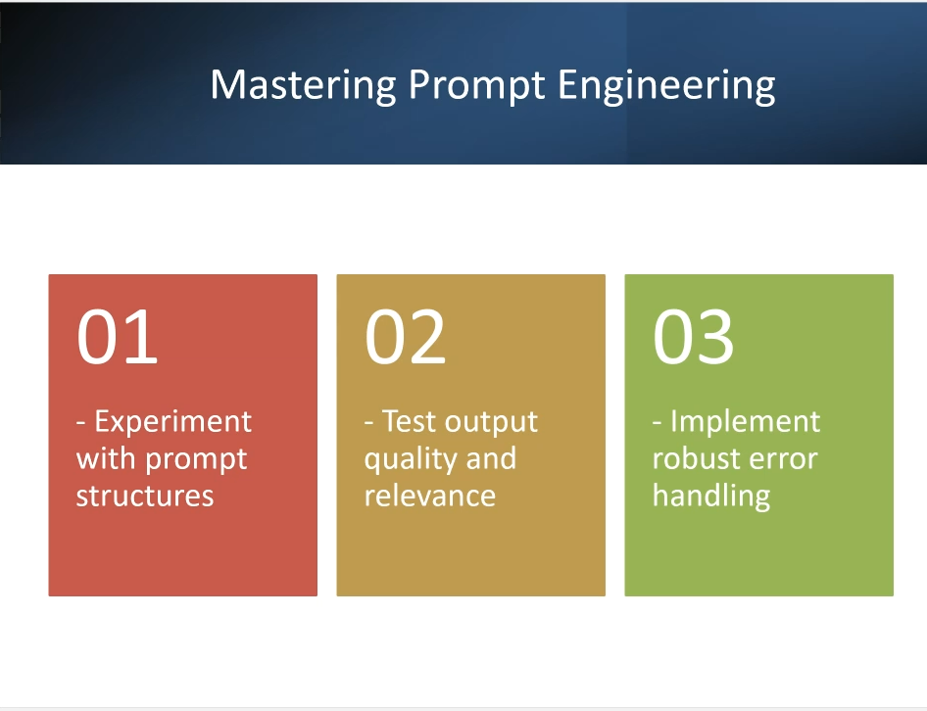  Prompt engineering: experiment, evaluate, and add robust error handling. | 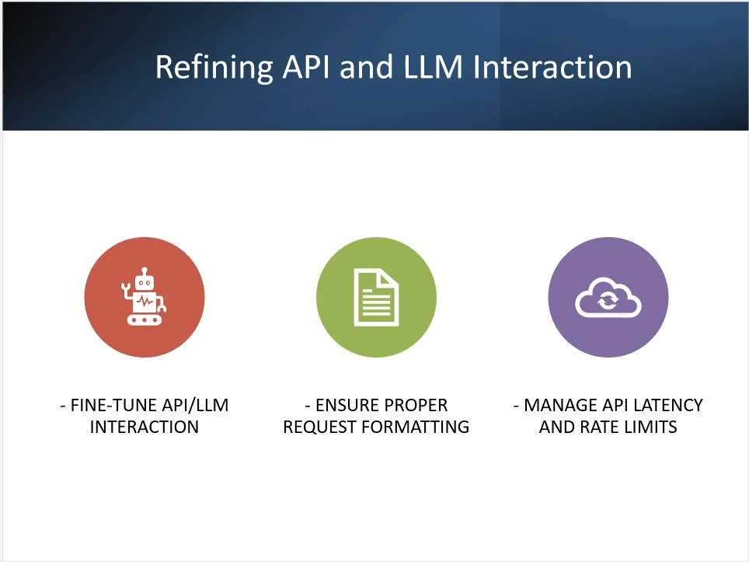  API/LLM refinement: request formatting, latency, and rate-limit handling.
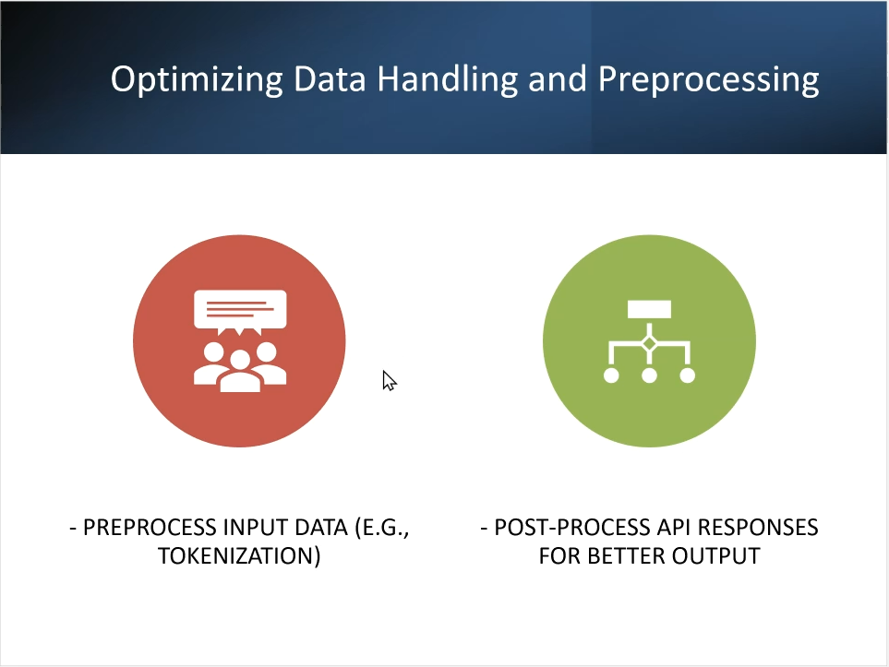  Input preprocessing and response post-processing. | 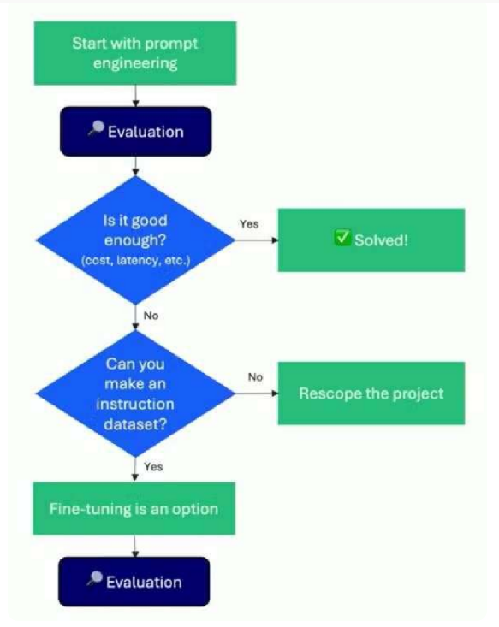  Evaluation loop: prompt first; fine-tuning only when justified by evidence.

E2 | DAY 4 EVIDENCE — TESTING, METRICS & TRUST
Evidence supporting evaluation, privacy, and the transition from the Day 2 prototype.
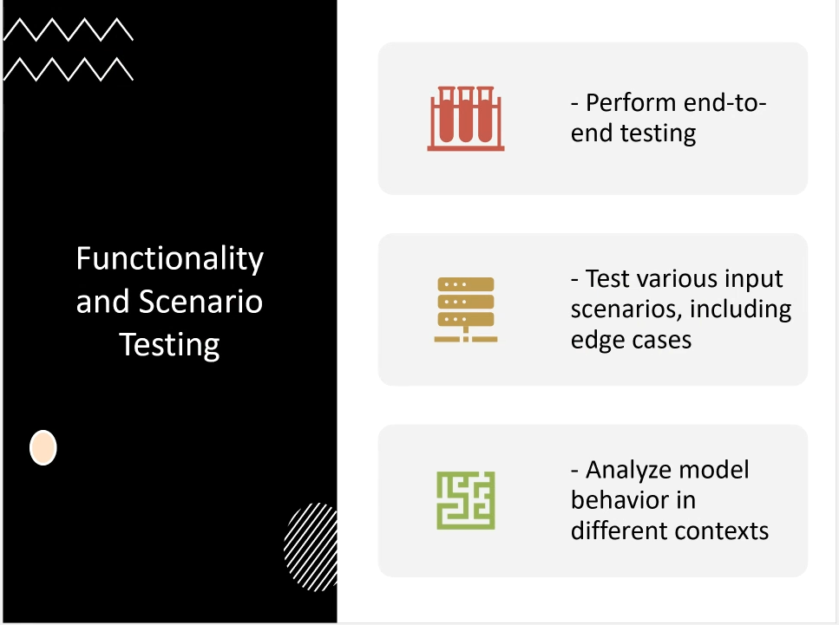  End-to-end, edge-case, and context testing. | 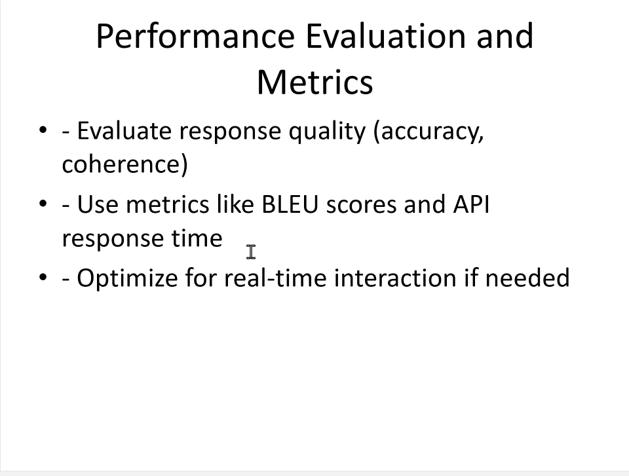  Accuracy, coherence, response-time, and supplemental text-generation metrics.
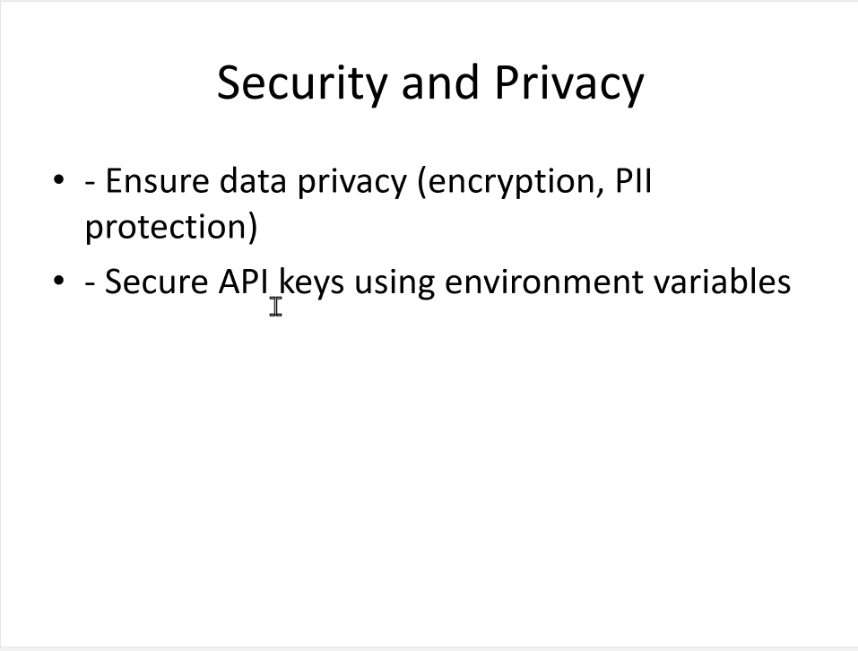  Privacy protection and server-side secret management. |   Starting point: the Day 2 interface that evolved into the Gemini-powered build.

10) Community Sharing Tracker (bonus points)
Use this to track your social proof and claim points.
Date | Platform | Post URL | What you shared | Tagged DDS? | Points claimed
7-9-2026 | LinkedIn | https://lnkd.in/p/dghs-DvH | My Project that I made | Yes | 150 Points

11) Reference Resources (from the challenge)
Core challenge walkthrough video: https://www.youtube.com/watch?v=X4PitcxNDjE
Python environment setup: https://www.youtube.com/watch?v=D5XyQ96EgiM&t=759s
GitHub basics: https://youtu.be/bV_9mr5O5bg?si=0oiiT9BZutcKCjnL
OpenAI API key setup: https://www.youtube.com/watch?v=CVnTzj-qhCU&t=8s
Model/LLM selection blogs:
• https://decodingdatascience.com/choosing-the-right-gemini-model-for-your-ai-project-a-beginner-friendly-guide/
• https://decodingdatascience.com/openai-guide-to-use-which-model-for-tasks/
• https://decodingdatascience.com/how-to-choose-the-right-openai-model-gpt-5-complete-guide/
AI Explorer RSVP: https://nas.io/artificialintelligence/events/ai-explorer-ai-demos-ai-use-cases-and-q-a-1767887350300

12) Reviewer / Mentor Notes (optional)
Use this section if an instructor/mentor is reviewing your progress.
Strengths observed:
•
Areas to improve next:
•
Action items:
•

Day 5 — Integration of Model/API with Interface
Checkpoint date: 9 September 2026 | Final Day 5 update: 12 September 2026
OBJECTIVE Create a smooth, functional user interface that connects learner input to the AI workflow, presents output clearly, handles errors and edge cases, and remains simple enough to maintain.

Interface selection and setup
I kept the existing responsive GitHub Pages interface and the working Google AI Studio Gemini deployment instead of introducing another framework only to satisfy the checkpoint. This gives judges a public project site plus a working AI experience while keeping provider credentials out of the browser.
• GitHub Pages: public project/interface showcase with Day 5 UI, evaluation, safety, project journey and deployment links.
• Google AI Studio: primary working Gemini-powered math assistant.
• Optional secure API path remains documented for server-side integration; secrets are not stored in the public frontend.
• The interface supports learning level, example prompts, status/progress feedback, response metrics, copy/regenerate, feedback, and Day 5 TXT/JSON export.
Backend-to-frontend communication
The learner flow is intentionally straightforward:
Question → Validate & preprocess → Math-only scope check → Secure AI path → Post-process → Display & export
• The client cleans and validates input before a request is attempted.
• Non-math prompts are refused locally so unrelated questions are not sent to the tutor.
• The UI provides loading/status feedback and friendly errors instead of raw technical failures.
• If the separate API route is unavailable, the project exposes a clear link to the working Google AI Studio Gemini assistant rather than pretending a local fallback is the live model.
User input and output handling
Area | Day 5 implementation | User benefit
Input | Math question textarea, learning-level selector, examples, 3000-character limit, approximate token count | Clear and guided question entry
Validation | Empty/long input checks, PII/secret patterns, math-only scope control | Safer and more predictable interaction
Progress | Thinking/status indicator, retry behavior, latency display | Users know what the app is doing
Output | Conversation view, structured response, copy/regenerate, feedback | Readable tutoring experience
Bonus | Download latest response as TXT or export JSON | Students can save results for later review
Testing the UI
• End-to-end flow: user input → validation → model/API path → formatted output.
• Algebra: “Solve 2x + 7 = 19 and explain every step.”
• Geometry: “Explain the Pythagorean theorem with a simple example.”
• Calculus: “Differentiate x^2 + 3x and explain the power rule.”
• Multi-turn follow-up: “Explain that more simply.”
• Edge cases: blank input, over-length input, non-math prompt, ambiguous input, unavailable API, mobile viewport and keyboard navigation.
• Controls: clear conversation, copy, regenerate, feedback, TXT download and JSON export.
AUTOMATED CHECKS 32/32 repository checks passed after the Day 5 changes, and JavaScript syntax checks passed. These are local/mock-backed tests; they do not replace a measured live-provider accuracy benchmark.

Error handling and debugging
• Friendly timeout, quota/rate-limit and invalid-response messages are retained from Day 4.
• Input validation prevents empty or oversized questions from entering the workflow.
• The math-only guard prevents the assistant from answering unrelated questions.
• The live Gemini application remains the primary working AI demo, reducing dependency on the earlier Cloudflare debugging path.
Refining the user experience
• Responsive dark EdTech interface with strong visual hierarchy and quick example prompts.
• Visible learning-level control and math-only scope message.
• Accessible labels, keyboard interaction, status announcements and reduced-motion support.
• Clear AI limitation notice: important calculations and academic work should be verified.
• No payment form, no credit-card requirement for learners, and no API key requested from students or teachers.
No-code / low-code tools: what I used and what I did not add
DDS provides many valid tool choices. The challenge guidance recommends choosing a tool based on the outcome and comfort level rather than trying to use every platform. The DDS tool guide also recommends starting with the outcome, using free tiers to explore, and combining tools only when each adds clear value.
Tool/path | Day 5 decision | Reason
Google AI Studio | Used | Working Gemini-powered live assistant and low-code/full-stack build environment.
GitHub Pages | Used | Public interface/project showcase and judge-friendly project URL.
LangSmith concepts | Retained as optional evaluation/observability path | Useful for prompt/eval quality, but no paid tracing is claimed as active.
Flowise / Voiceflow | Not added | A second chatbot builder would duplicate the current working interface.
Make.com | Not added yet | Automation is not required for the core math-tutoring Day 5 flow.
Gradio / Streamlit | Not added | The current deployed UI already satisfies the interface goal; adding another UI would increase complexity.
Hugging Face / Replit / v0 / Lovable | Optional future alternatives | Useful platforms, but not necessary for the current deployed architecture.
Bonus challenge
• Deployment is already available through the working Google AI Studio app and GitHub Pages project site.
• Day 5 adds download/export controls for the latest response as TXT and JSON in the GitHub-ready package.
Challenges, limitations and solutions
• Challenge: the earlier separate Cloudflare path created integration friction. Solution: keep secrets server-side and use the working AI Studio deployment as the primary live assistant.
• Challenge: a static GitHub Pages site cannot safely hold a Gemini API key. Solution: never place provider secrets in public JavaScript; GitHub Pages acts as the public project/interface layer.
• Limitation: the current automated test result is not a live Gemini accuracy score. A measured live-provider evaluation should be captured before making accuracy or latency claims.
• Limitation: AI explanations can still be wrong. The interface retains verification guidance and deterministic checks for supported calculations.
Day 5 deliverables
• Working interface allowing users to reach and interact with the AI math assistant.
• Progress report covering setup, backend/frontend flow, testing, challenges and solutions.
• Updated GitHub-ready code, README and Day 5 documentation.
• Interface evidence/screenshots supplied with the checkpoint materials.
• Deployment links included below.
Project links
• Repository: https://github.com/Nevin-CS/nevin-chatbot-ai-math-learning-assistant
• GitHub Pages: https://nevin-cs.github.io/nevin-chatbot-ai-math-learning-assistant/
• Live Gemini app: https://nevin-chatbot-ai-math-learning-assistant.ai.studio/
Day 6 handoff
Day 6 will focus on final enhancements, security and debugging: regression testing, failure-path checks, privacy/security review, mobile polish, deployment verification, and preparation for the final review/deployment checkpoint.

Day 5 Evidence Appendix
Selected checkpoint reference images supplied for Day 5. These are used as supporting evidence and planning references, not as claims that every listed platform was used.
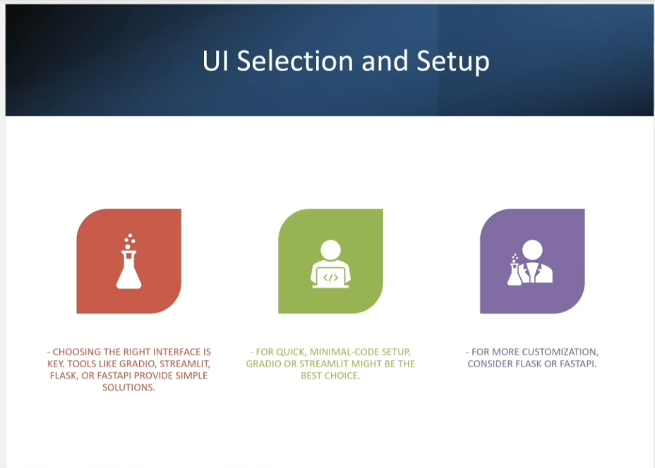
Figure 1. UI selection and setup reference.
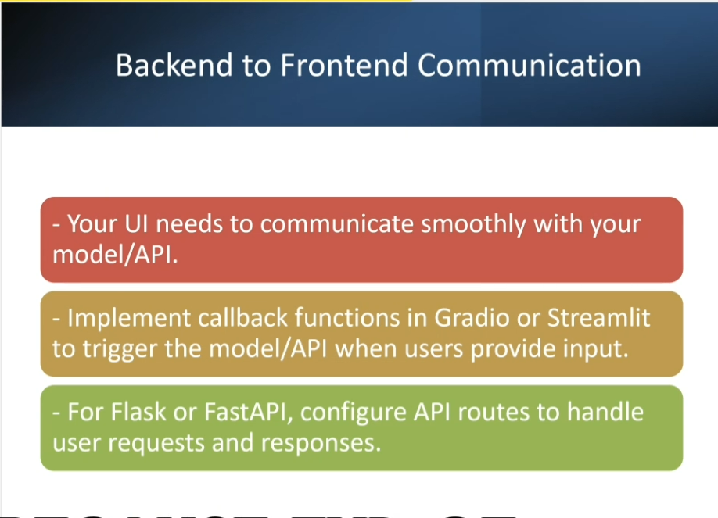
Figure 2. Backend-to-frontend communication reference.
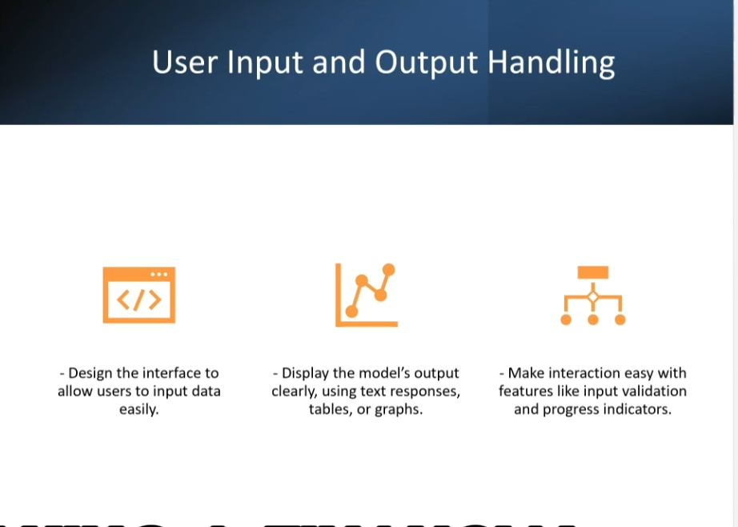
Figure 3. User input and output handling reference.
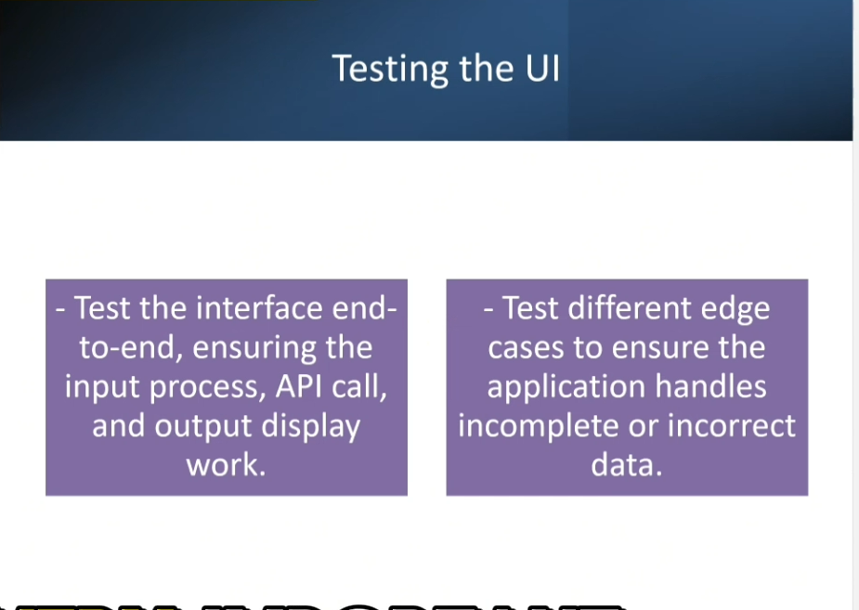
Figure 4. End-to-end and edge-case UI testing reference.
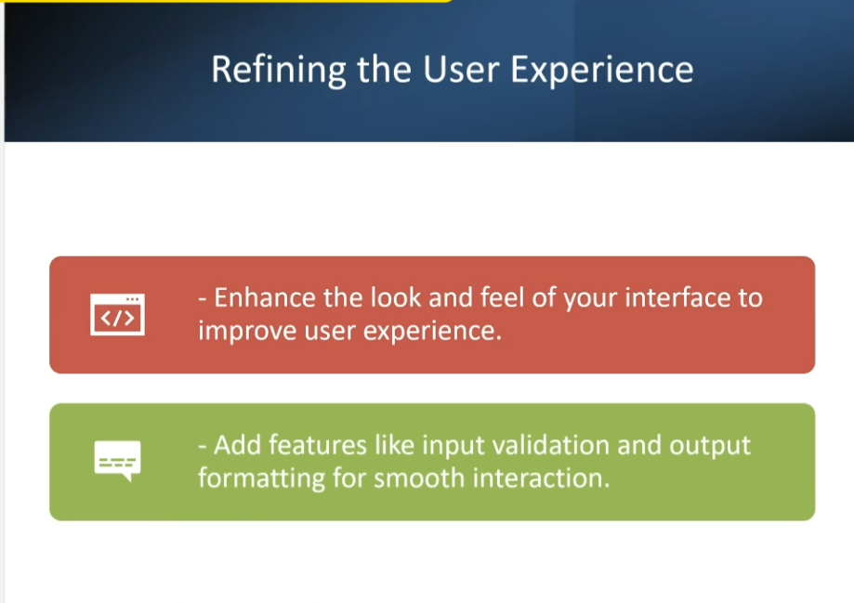
Figure 5. User-experience refinement reference.
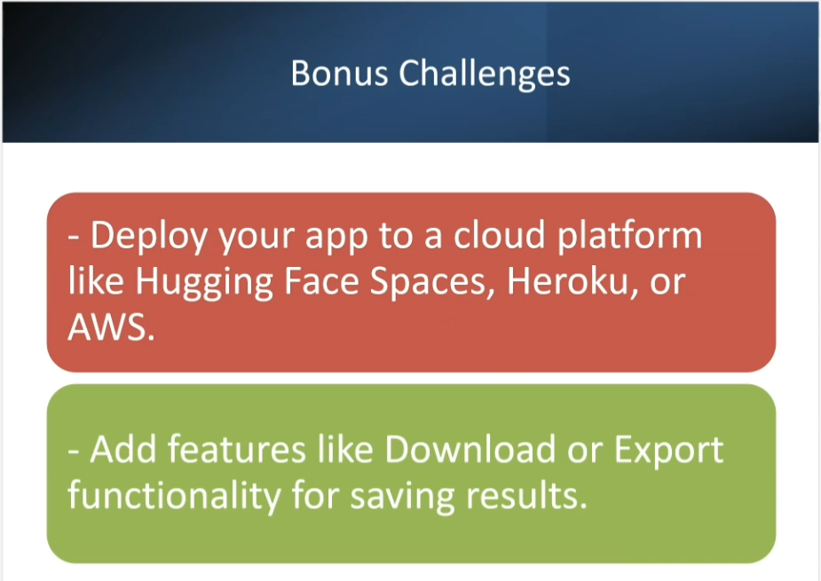
Figure 6. Bonus deployment/export challenge reference.
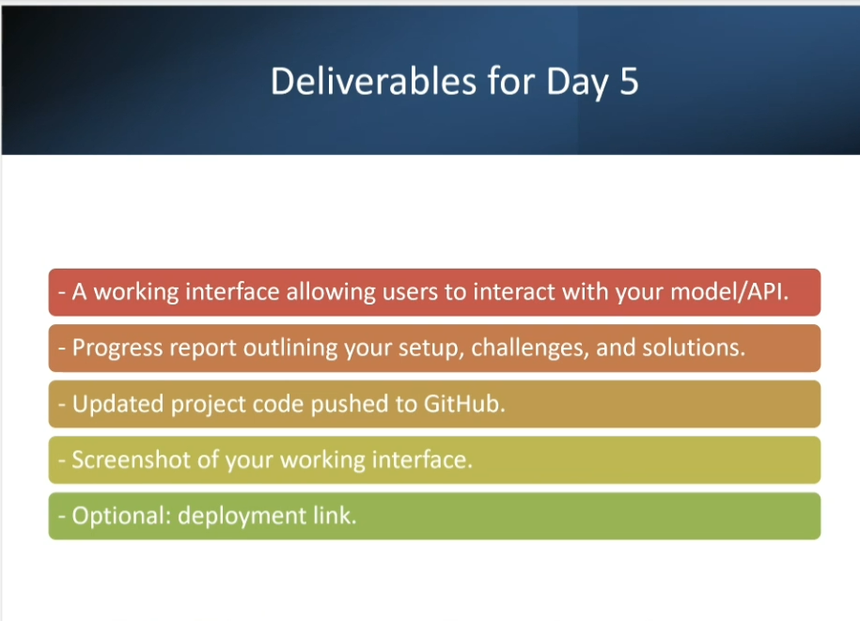
Figure 7. Day 5 deliverables reference.
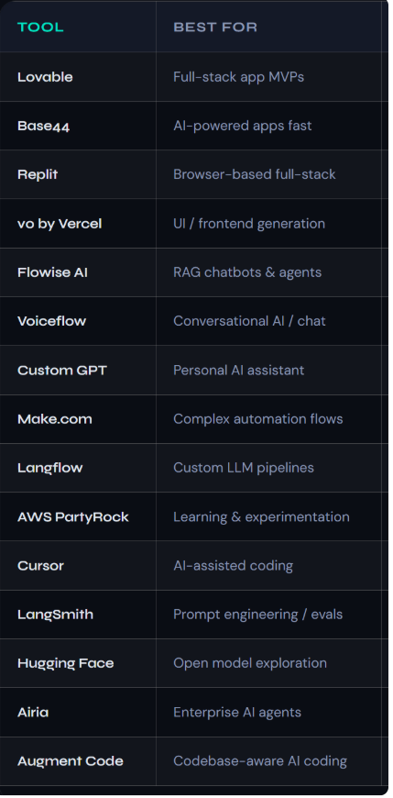
Day 6 — Final Enhancements, Security & Debugging
Nevin Chatbot · DDS Building Agentic AI Application Challenge 2026 · Progress documented 12 September 2026

Day 6 objective
Refine the LLM/API integration, strengthen trust and privacy controls, test difficult inputs and failure paths, improve responsiveness and user feedback, and prepare one organized GitHub repository for the Day 7 final review.
Current product status
The live Gemini application is working in Google AI Studio. GitHub Pages provides the public project site, evaluation story, safety information and direct launch path. The Day 6 package adds layered security checks, regression tests and an honest unresolved-issues record.

Project links
GitHub repository | https://github.com/Nevin-CS/nevin-chatbot-ai-math-learning-assistant
GitHub Pages | https://nevin-cs.github.io/nevin-chatbot-ai-math-learning-assistant/
Live Gemini app | https://nevin-chatbot-ai-math-learning-assistant.ai.studio/
Day 6 completion checklist
Status | Day 6 item
Complete | Prompt instructions refined for scope, clarity, ambiguity, privacy and non-disclosure.
Complete | Common prompt-injection patterns blocked before provider access.
Complete | PII, API-key and secret-pattern checks strengthened on input and output.
Complete | Only read-only mathematics verification tools are allowlisted.
Complete | Token/history limits, timeout, retry backoff, expiring cache and duplicate-submit protection added.
Complete | Friendly errors, loading/status feedback and Google AI Studio fallback retained.
Complete | 44/44 automated local checks passed; JavaScript syntax checks passed.
Pending live evidence | Run and record a full live Gemini benchmark before claiming an accuracy or latency percentage.
Pending Day 7 | Add final demo-video URL and complete final deployment review.

Day 6 Engineering Improvements
Prompt optimization · edge cases · performance · errors · final UX

1. Prompt optimization
• Added a clear instruction hierarchy: user content is treated as untrusted learning content and cannot override the mathematics-only role or security rules.
• Required a focused clarification question when a mathematics request is incomplete or ambiguous.
• Kept the answer structure concise and teachable: Concept → Step-by-step solution → Verification → Final answer → Learning tip.
• Added explicit non-disclosure rules for hidden instructions, credentials, environment variables and private reasoning.
• Reduced unnecessary context by limiting history to the latest 10 turns and approximately 1,400 characters per stored message.
2. Edge cases and fallbacks
Scenario | Expected handling
Empty / whitespace input | Reject before API call with a clear instruction.
Ambiguous math question | Ask one focused clarification question.
Non-math question | Return a math-only refusal without sending unrelated content.
Prompt injection attempt | Block safely and do not call the model.
PII / API key in input | Reject and request removal before processing.
Overlength / high token estimate | Ask the learner to shorten the question.
Timeout / quota / rate limit | Show a friendly message; retry only transient failures.
Provider unavailable | Use a deterministic local answer only when a supported math tool can verify it; otherwise link to the live Gemini app.
Unsafe model output | Strip HTML and block secret-like or internal-instruction content.
3. Performance tuning
• Changed the request timeout to 18 seconds and kept one controlled retry with short backoff for transient failures.
• Added a 15-minute session-cache expiry for repeated questions while avoiding persistent storage of AI answers.
• Added a 900 ms minimum interval between submissions and retained the busy-state lock to avoid accidental duplicate API calls.
• Limited prompt length to 3,000 characters and an estimated 900 input tokens; shortened retained conversation context.
• Latency remains visible in the interface, but no guaranteed response-time claim is made.
4. Final UX enhancements
• Visible loading/status states, clear retry path and friendly user-facing errors.
• Learning-level selector, quick example prompts, keyboard operation and reduced-motion support.
• Copy, regenerate, local feedback, TXT download and JSON export remain available.
• A prominent link opens the working Gemini application when the optional separate API route is unavailable.

Security, Privacy & Tool Governance
Layered controls for prompt injection, data leakage and tool misuse

Key risk controls
Risk | Control | Status
Prompt injection | Client and server pattern checks for instruction override, jailbreak, system-prompt extraction and credential-exposure attempts. | Implemented
Data leakage | Input checks for email, phone-like numbers and common secret/token formats; output checks block secret-like values and internal-instruction markers. | Implemented
Tool misuse | Server computes trusted tool results itself and ignores untrusted client-supplied tool output. Only read-only arithmetic and linear-equation tools are allowlisted. | Implemented
API credentials | Gemini key remains in hosted/server environment secrets, never in GitHub Pages files or screenshots. | Implemented
Origin abuse | Optional Worker uses exact-origin CORS and request/body limits. | Implemented
Residual LLM risk | Visible limitation notice and deterministic verification where supported; no claim of perfect accuracy. | Open / monitored
Security tools reviewed
Tool / practice | Day 6 decision
LLM Guard | Useful for server-side prompt/output scanning. Not installed in this lightweight browser/Worker build.
Guardrails AI | Useful for schema and output validation in a Python backend. Native JavaScript checks are used now.
Microsoft Prompt Shields | A possible future managed prompt-injection layer. Not claimed as integrated.
ModelScan | Designed for unsafe serialized model files; not applicable because the project calls a hosted Gemini model and loads no local model artifact.
LangChain output parsers | Not required in the current JavaScript/AI Studio architecture; response structure is checked natively.
Role-based tool access | Implemented through an allowlist. Students and teachers receive only the two read-only math tools.
Important limitation
No single pattern list or guardrail guarantees complete prompt-injection prevention. The design therefore combines scope restriction, input/output checks, least-privilege tools, server-side secrets, honest limitations and continuous testing.

Reference sources reviewed
• LLM Guard quickstart: https://protectai.github.io/llm-guard/get_started/quickstart/
• Protect AI ModelScan: https://github.com/protectai/modelscan
• Guardrails AI: https://github.com/guardrails-ai/guardrails
• Microsoft Prompt Shields: https://learn.microsoft.com/azure/ai-services/content-safety/concepts/jailbreak-detection

Testing Results, Limitations & Day 7 Handoff
Evidence-led progress without unsupported claims

Automated checks
44 / 44 local automated checks passed
The suite covers scope control, preprocessing, token/history limits, sensitive-data checks, prompt-injection patterns, least-privilege tools, deterministic math verification, output cleanup, API routes, mocked Gemini parsing, SEO, accessibility and secret scanning. JavaScript syntax checks also passed.

Testing completed or prepared
Test area | Coverage
Functional | Arithmetic, algebra, geometry, calculus, probability, concept explanation and multi-turn follow-up.
Edge cases | Empty, ambiguous, too long, rapid repeat, non-math, PII/secret-like and provider-failure inputs.
Security | Prompt override, hidden-instruction extraction, client tool tampering, origin mismatch and unsafe HTML/secret-like output.
Performance | Token estimate, 10-turn context, 18-second timeout, retry backoff, expiring cache and latency display.
UI | Loading, retry, copy, regenerate, feedback, export, mobile layout, keyboard flow and reduced motion.
Unresolved issues and honest limitations
• A complete live-provider benchmark has not yet been recorded, so no Gemini accuracy percentage, average latency or zero-error claim is made.
• Pattern-based prompt-injection checks can miss novel attacks or flag legitimate text; layered controls and monitoring remain necessary.
• The Worker in-memory rate limiter is best-effort and is not a durable production quota system.
• Google AI Studio or Gemini quotas and availability are external dependencies.
• AI-generated mathematics can still be wrong; verification guidance remains visible and deterministic checking is limited to supported calculations.
• No final demo-video file or URL was supplied yet; `media/VIDEO_LINKS.md` contains the Day 7 placeholder.
Repository organization for one-place submission
• Root: live website files, README, security notes and Day 6 submission notes.
• `src/`, `tests/`, `security/`, `evaluation/`, `backend/`: implementation and evidence.
• `docs/`: Day 5/Day 6 design, testing and handoff notes plus checkpoint screenshots.
• `submissions/challenge-history/`: Day 1 through Day 5 Word submissions.
• `submissions/`: Day 6 DOCX and PDF added after final rendering.
• `media/`: video-link index and instructions for adding the final Day 7 demo.
Day 7 preparation
• Verify the repository, GitHub Pages and Google AI Studio links from a private/incognito browser window.
• Run `npm test` and `npm run check` after the final upload.
• Capture one successful math conversation, one math-only refusal and one prompt-injection block as evidence.
• Record a 2–3 minute final demonstration and add the URL to `media/VIDEO_LINKS.md`.
• Complete final deployment smoke tests on desktop and mobile.
• Submit the final app, repository, workbook/PDF, screenshots and video link.

Day 6 Evidence Appendix
Selected challenge guidance and updated project evidence

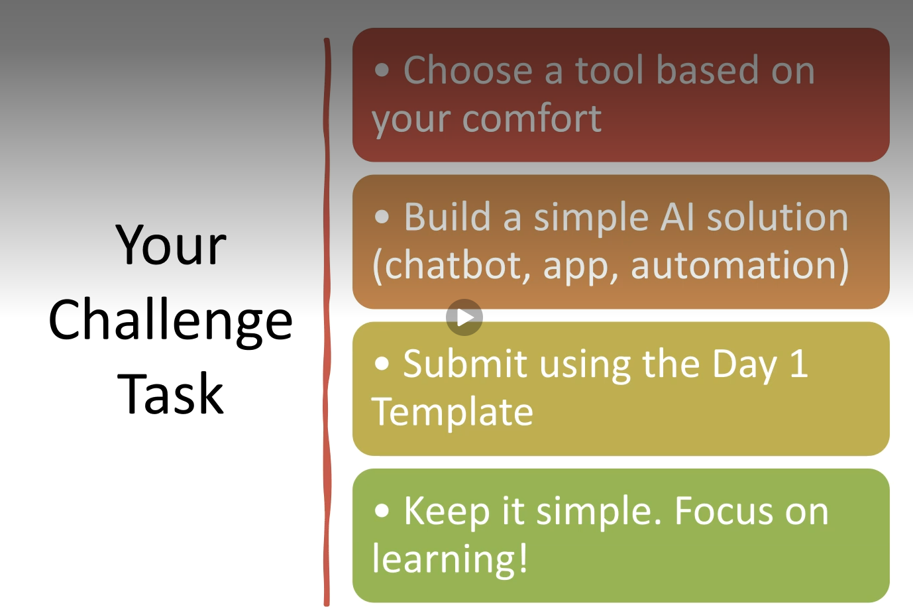
Figure 1. Day 6 checkpoint guidance: prompt optimization, edge cases, performance, errors and final UX.

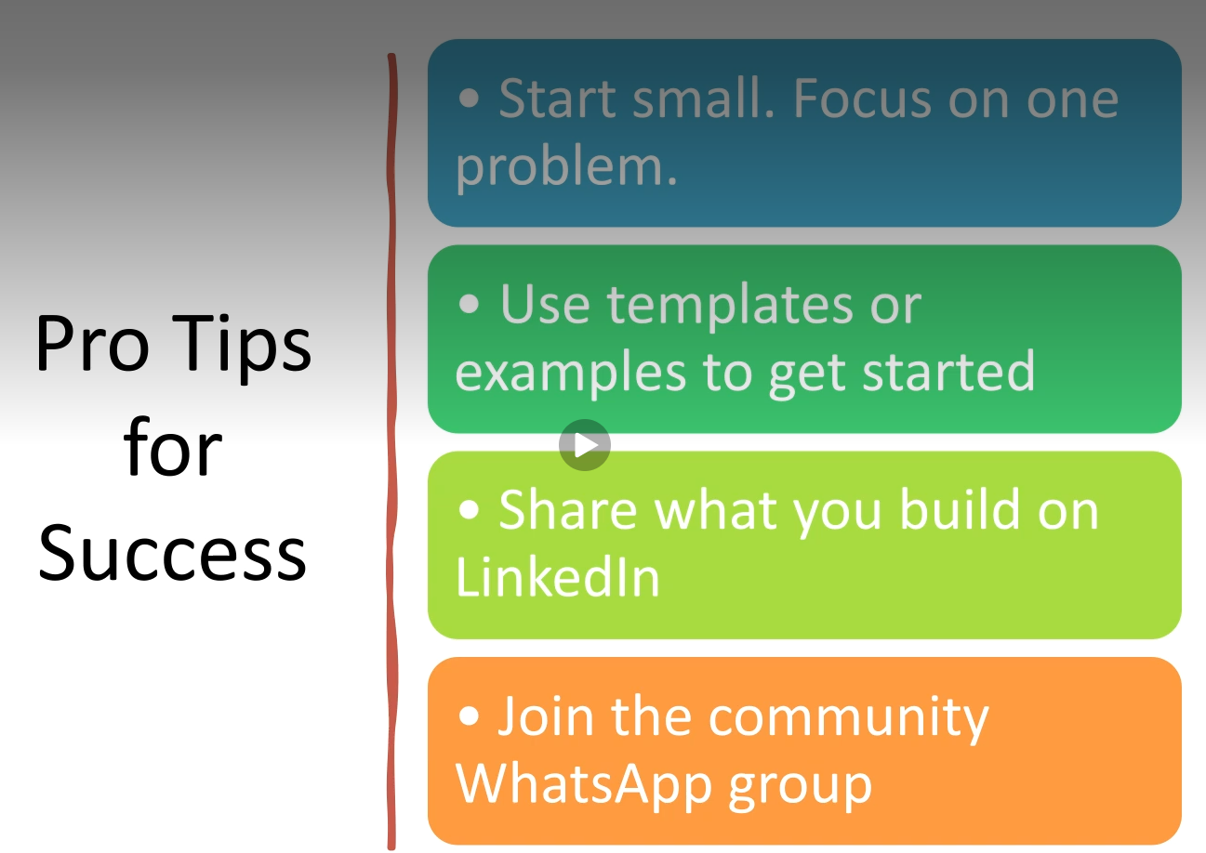
Figure 2. Challenge pro tips: stay focused, use templates, share progress and engage with the community.


Figure 3. DDS no-code/low-code tool reference. The project uses Google AI Studio and GitHub rather than adding duplicate interfaces.

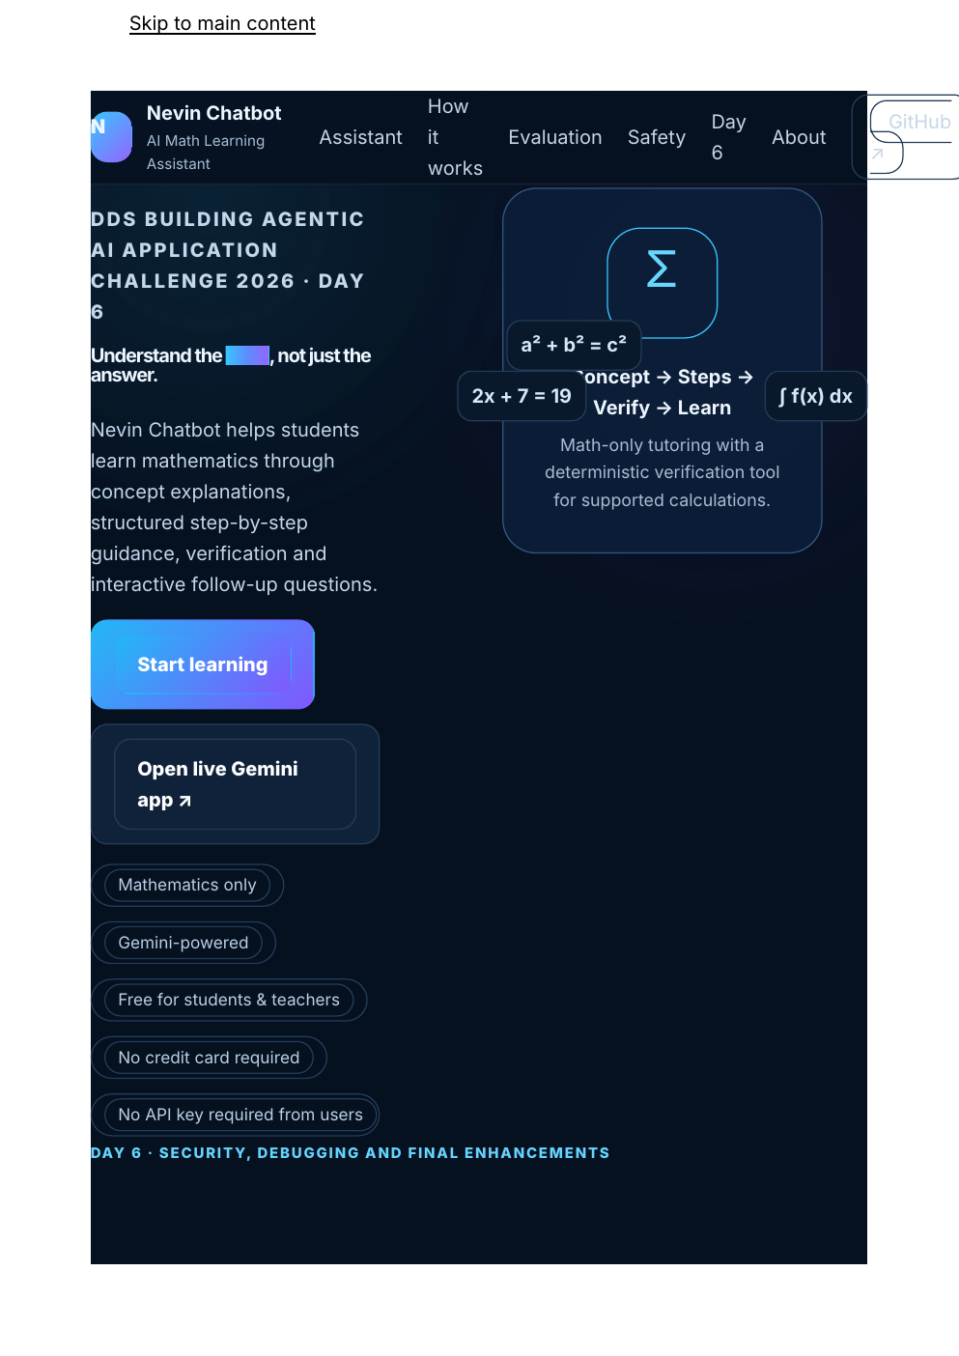
Figure 4. Locally rendered Day 6 GitHub Pages update showing the hardened project experience.

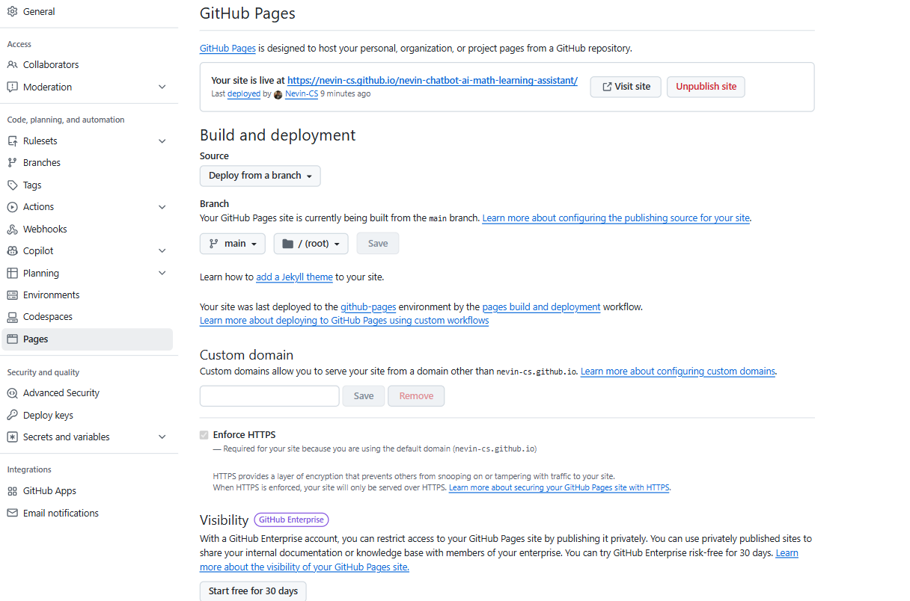
Figure 5. GitHub Pages deployment settings and published project site evidence.

